**评估板硬件和软件部分详细介绍**

**1、硬件原理图：详见“硬件原理图”文件夹**

（1）硬件接口定义：

|  |  |  |
| --- | --- | --- |
| 功能 | 对应STM32F103的IO |  |
| KEY1（屏幕亮度开关） | PB10 |  |
| KEY2（温度+） | PB11 |  |
| KEY3（温度-） | PB12 |  |
| KEY4（播放/停止） | PB13 |  |
| KEY5（音量+） | PB14 |  |
| KEY6（音量-） | PB15 |  |
| LED1 | PC10 |  |
| LED2 | PC3 |  |
| LED3 | PC2 |  |
| LED4 | PC0 |  |
| LED5 | PC13 |  |
| TXD2(触摸屏端子显示) | PA10 |  |
| RXD2(触摸屏端子显示) | PA9 |  |

（2）硬件原理图：

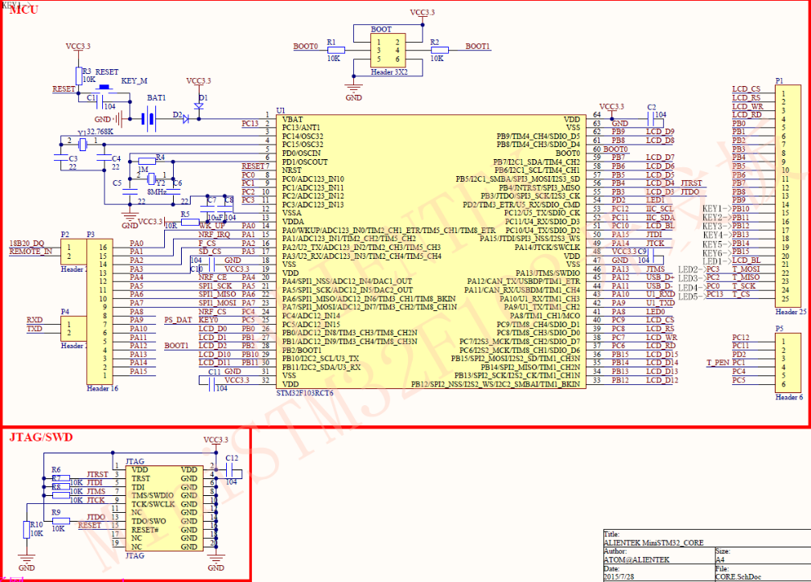

*图1：STM32F103原理图*

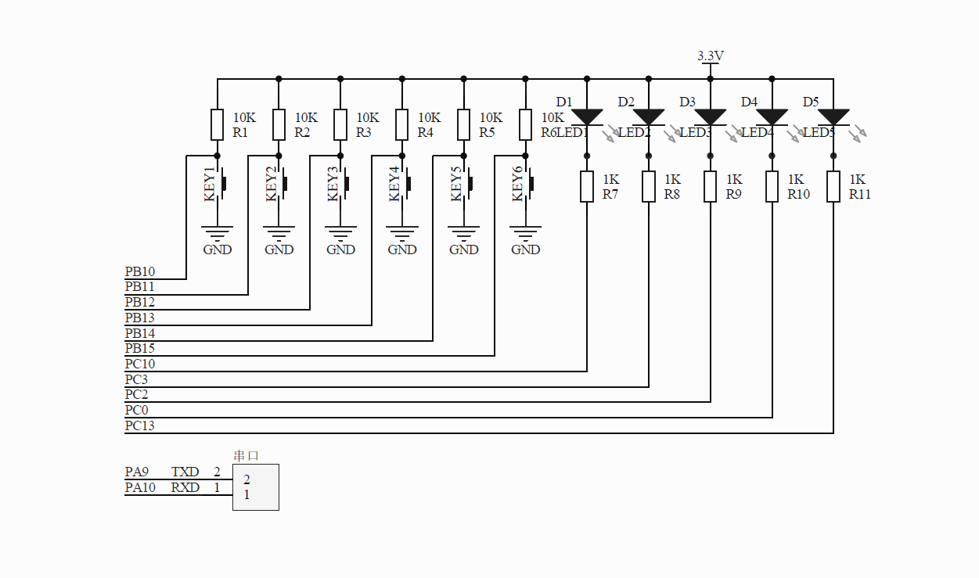

*图2：LED及KEY原理图*

**2、软件程序**

界面工程文件在“DGUS_II工程”文件夹中。STM32程序在“MCU_STM32F103RCT6程序”文件夹中。

（1）界面工程

LED1图标：0X1000

LED1按键：0X1200

LED2图标：0X1001

LED2按键：0X1201

LED3图标：0X1002

LED3按键：0X1202

LED4图标：0X1003

LED4按键：0X1203

LED5图标：0X1004

LED5按键：0X1204

音量显示框地址：0X1210

温度显示框地址：0X1110

（2）MCU程序

1）.main():硬件初始化，触摸屏初始化，按键扫描，接收触摸屏数据处理

int main(void)

{

uint8_t i;

HAL_Init();

SystemClock_Config();

MX_GPIO_Init();

MX_USART1_UART_Init();

while (1)

{

HAL_UART_Receive_IT(&huart1,&usart1_data,1);

if(UP_POWER_FLAG == 0)//上电初始化触摸屏

{

UP_POWER_FLAG = 1;

HMI_SEND_BUF[0] = TEMP;

PLC_Data_Wr2HMI(0X1110,0,1);

delay_ms(100);

HMI_SEND_BUF[0] = VOLUME;

PLC_Data_Wr2HMI(0X1210,0,1);//ÒôÁ¿ÏÔÊ¾

delay_ms(100);

WRITE_HMI(0X00A1,VOLUME,0x00,0,0,2);//Ä¬ÈÏÒôÁ¿50

delay_ms(100);

for(i=0;i<5;i++)

{

HMI_SEND_BUF[i] = 0;

}

for(i=0;i<20;i++)

{

usart1_rxBuf[i] = 0x00;

}

HMI_HANDLEFLAG = 0;

}

if(PLAY ==1)//监测是否播放完音乐

{

READ_HMI(0x00a1,1);

delay_ms(100);

if(HMI_HANDLEFLAG)

{

if(usart1_rxBuf[8] == 0)

{

PLAY = 0;

for(i=0;i<50;i++)

{

usart1_rxBuf[i] = 0x00;

}

usart1_counter = 0;

}

}

}

SCAN_KEY(0);//按键扫描

if(HMI_HANDLEFLAG)//接收触摸屏数据处理

{

HMI_HANDLEFLAG = 0;

CLOSE_OPEN_IO(0x01);

CLOSE_OPEN_IO(0x02);

CLOSE_OPEN_IO(0x03);

CLOSE_OPEN_IO(0x04);

CLOSE_OPEN_IO(0x05);

for(i=0;i<50;i++)

{

usart1_rxBuf[i] = 0x00;

}

usart1_counter = 0;

}

}

2）. PLC_Data_Wr2HMI ():数据写入触摸屏变量寄存器

void PLC_Data_Wr2HMI(uint16_t HMI_start_addr,uint16_t PLC_return_data_start_addr,uint8_t len)

{

uint8_t i;

usart1_txBuf[0]=0x5a;

usart1_txBuf[1]=0xa5;

usart1_txBuf[2]=len*2+3;

usart1_txBuf[3]=0x82;

usart1_txBuf[4]=((uint8_t)(HMI_start_addr>>8))&0XFF;

usart1_txBuf[5]=(uint8_t)(HMI_start_addr&0XFF);

for(i=0;i<len;i++)

{

usart1_txBuf[i*2+6]=((HMI_SEND_BUF[i+PLC_return_data_start_addr] >>8)&0xff);

usart1_txBuf[i*2+7]=(HMI_SEND_BUF[i+PLC_return_data_start_addr] &0xff);

}

HAL_UART_Transmit(&huart1, usart1_txBuf, len*2+6, 10);//串口发送

}

3）. WRITE_HMI ():数据写入触摸屏寄存器

void WRITE_HMI(uint16_t addr,uint8_t data1,uint8_t data2,uint8_t data3,uint8_t data4,uint8_t len)

{

usart1_txBuf[0]=0x5a;

usart1_txBuf[1]=0xa5;

usart1_txBuf[2]=len*2+3;

usart1_txBuf[3]=0x82;

usart1_txBuf[4]=(uint8_t)((addr>>8)&0xff);

usart1_txBuf[5]=(uint8_t)(addr&0xff);

usart1_txBuf[6]=data1;

usart1_txBuf[7]=data2;

usart1_txBuf[8]=data3;

usart1_txBuf[9]=data4;

HAL_UART_Transmit(&huart1, usart1_txBuf, len*2+6 , 20);

}

4）. READ_HMI ():读触摸屏寄存器数据

void READ_HMI(uint16_t addr,uint8_t num)

{

usart1_txBuf[0]=0x5a;

usart1_txBuf[1]=0xa5;

usart1_txBuf[2]=0x04;

usart1_txBuf[3]=0x83;

usart1_txBuf[4]=(uint8_t)((addr>>8)&0xff);

usart1_txBuf[5]=(uint8_t)(addr&0xff);

usart1_txBuf[6]=num;

HAL_UART_Transmit(&huart1, usart1_txBuf, 7 , 20);

}

5). CLOSE_OPEN_IO ():开关LED

void CLOSE_OPEN_IO(uint8_t hmi_key_value)

{

uint8_t i;

if(usart1_rxBuf[7] == 0x00&&usart1_rxBuf[8] == hmi_key_value)//LED1

{

if(LED_FLAG[hmi_key_value-1] == 0)

{

if(hmi_key_value == 0x01)

{

HAL_GPIO_WritePin(GPIOC, GPIO_PIN_10, GPIO_PIN_RESET);//开LED1

}

if(hmi_key_value == 0x02)

{

HAL_GPIO_WritePin(GPIOC, GPIO_PIN_3, GPIO_PIN_RESET); //开LED2

}

if(hmi_key_value == 0x03)

{

HAL_GPIO_WritePin(GPIOC, GPIO_PIN_2, GPIO_PIN_RESET); //开LED3

}

if(hmi_key_value == 0x04)

{

HAL_GPIO_WritePin(GPIOC, GPIO_PIN_0, GPIO_PIN_RESET); //开LED4

}

if(hmi_key_value == 0x05)

{

HAL_GPIO_WritePin(GPIOC, GPIO_PIN_13, GPIO_PIN_RESET); //开LED5

}

LED_FLAG[hmi_key_value-1] = 1;

}

else if(LED_FLAG[hmi_key_value-1] == 1)

{

if(hmi_key_value == 0x01)

{

HAL_GPIO_WritePin(GPIOC, GPIO_PIN_10, GPIO_PIN_SET);//关LED1

}

if(hmi_key_value == 0x02)

{

HAL_GPIO_WritePin(GPIOC, GPIO_PIN_3, GPIO_PIN_SET); //关LED2

}

if(hmi_key_value == 0x03)

{

HAL_GPIO_WritePin(GPIOC, GPIO_PIN_2, GPIO_PIN_SET); //关LED3

}

if(hmi_key_value == 0x04)

{

HAL_GPIO_WritePin(GPIOC, GPIO_PIN_0, GPIO_PIN_SET); //关LED4

}

if(hmi_key_value == 0x05)

{

HAL_GPIO_WritePin(GPIOC, GPIO_PIN_13, GPIO_PIN_SET); //关LED5

}

LED_FLAG[hmi_key_value-1] = 0;

}

for(i=0;i<9;i++)

{

usart1_rxBuf[i] = 0xff;

}

for(i=0;i<5;i++)

{

HMI_SEND_BUF[i] = LED_FLAG[i];

}

PLC_Data_Wr2HMI(0X1000,0,5);//发送LED状态到触摸屏，改变LED显示图标；

delay_ms(50);

}

}

6). CLOSE_OPEN_IO ():开关LED

void SCAN_KEY(uint8_t io_key_value)

{

uint8_t i;

if(HAL_GPIO_ReadPin(GPIOB,GPIO_PIN_10)==GPIO_PIN_RESET)//KEY1按下

{

delay_ms(150);//去抖

if(HAL_GPIO_ReadPin(GPIOB,GPIO_PIN_10)==GPIO_PIN_RESET)

{

if(HMI_FLAG[0] == 0)

{

WRITE_HMI(0X82,0x00,0x00,0,0,1);//熄灭屏幕

HMI_FLAG[0] = 1;

}else if(HMI_FLAG[0] == 1)

{

WRITE_HMI(0X82,0X64,0x00,0,0,1);//点亮屏幕

HMI_FLAG[0] = 0;

}

}

for(i=0;i<50;i++)

{

usart1_rxBuf[i] = 0x00;

}

usart1_counter = 0;

}

if(HAL_GPIO_ReadPin(GPIOB,GPIO_PIN_11)==GPIO_PIN_RESET)//KEY2按下

{

delay_ms(150);//去抖

if(HAL_GPIO_ReadPin(GPIOB,GPIO_PIN_11)==GPIO_PIN_RESET)

{

TEMP += 1;

HMI_SEND_BUF[0] = TEMP;

PLC_Data_Wr2HMI(0X1110,0,1);//温度+

}

for(i=0;i<50;i++)

{

usart1_rxBuf[i] = 0x00;

}

usart1_counter = 0;

}

if(HAL_GPIO_ReadPin(GPIOB,GPIO_PIN_12)==GPIO_PIN_RESET)//KEY3按下

{

delay_ms(150);//去抖

if(HAL_GPIO_ReadPin(GPIOB,GPIO_PIN_12)==GPIO_PIN_RESET)

{

TEMP -= 1;

HMI_SEND_BUF[0] = TEMP;

PLC_Data_Wr2HMI(0X1110,0,1);//温度-

}

for(i=0;i<50;i++)

{

usart1_rxBuf[i] = 0x00;

}

usart1_counter = 0;

}

if(HAL_GPIO_ReadPin(GPIOB,GPIO_PIN_13)==GPIO_PIN_RESET)//KEY4按下

{

delay_ms(150);//去抖

if(HAL_GPIO_ReadPin(GPIOB,GPIO_PIN_13)==GPIO_PIN_RESET)

{

if(PLAY == 0)

{

WRITE_HMI(0X00A0,0X00,0x0E,0,0,1);

PLAY =1;//播放

}else if(PLAY == 1)

{

WRITE_HMI(0X00A0,0X00,0x00,0,0,1);

PLAY =0;//停止

}

}

for(i=0;i<50;i++)

{

usart1_rxBuf[i] = 0x00;

}

usart1_counter = 0;

}

if(HAL_GPIO_ReadPin(GPIOB,GPIO_PIN_14)==GPIO_PIN_RESET)//KEY5按

{

delay_ms(150);//去抖

if(HAL_GPIO_ReadPin(GPIOB,GPIO_PIN_14)==GPIO_PIN_RESET)

{

if(VOLUME<250)

{

VOLUME += 10;

WRITE_HMI(0X00A1,VOLUME,0x00,0,0,2);//音量+

delay_ms(50);

HMI_SEND_BUF[0] = VOLUME;

PLC_Data_Wr2HMI(0X1210,0,1);//写当前音量到触摸屏

delay_ms(50);

}

}

for(i=0;i<50;i++)

{

usart1_rxBuf[i] = 0x00;

}

usart1_counter = 0;

}

if(HAL_GPIO_ReadPin(GPIOB,GPIO_PIN_15)==GPIO_PIN_RESET)//KEY6按下

{

delay_ms(150);//去抖

if(HAL_GPIO_ReadPin(GPIOB,GPIO_PIN_15)==GPIO_PIN_RESET)

{

if(VOLUME >= 10)

{

VOLUME -= 10;

WRITE_HMI(0X00A1,VOLUME,0x00,0,0,2);//音量-

delay_ms(50);

HMI_SEND_BUF[0] = VOLUME;

PLC_Data_Wr2HMI(0X1210,0,1);//写当前音量到触摸屏

delay_ms(50);

}

}

for(i=0;i<50;i++)

{

usart1_rxBuf[i] = 0x00;

}

usart1_counter = 0;

}

}

7). delay_ms ():延时函数，不精确慎用

void delay_ms(uint16_t nms)

{

uint16_t i,j;

for(i=0;i<nms;i++)

{

for(j=0;j<10000;j++)

{

;

}

}

}

8). USART1_IRQHandler ():数据接收中断

void USART1_IRQHandler(void)

{

HAL_UART_IRQHandler(&huart1);

if(usart1_rxBuf[0] == 0x5a&&usart1_rxBuf[1] == 0xa5&&usart1_rxBuf[2])

{

if(usart1_counter >= 3&&usart1_counter<(usart1_rxBuf[2]+3))

{

usart1_rxBuf[usart1_counter] = usart1_data;

usart1_counter++;

}

if(usart1_counter >= 3&&usart1_counter>=(usart1_rxBuf[2]+3))

{

HMI_HANDLEFLAG = 1;//接收完成标志

}

}

if(usart1_counter < 3)

{

usart1_rxBuf[usart1_counter] = usart1_data;

usart1_counter++;

}

if(HMI_HANDLEFLAG)

{

usart1_counter = 0;

}

HAL_UART_Receive_IT(&huart1,&usart1_data,1);//开接收中断

}